
CSA 1016 SOFTWARE ENGINEERING
Medication Adherence Tracker for Elderly Patients with Caregiver Alerts
AGILE SPRINT PLANNING &USER STORY WORKSHOP
NAME: ALIMA BANU R
REG NO: 192471044
GUIDE NAME: ANITA DAVAMANI K

Table of Contents
Table of Contents 1
1. Introduction 1
1.1 Purpose of the Report 1
1.2 Scope of This Planning Document 1
2. Project Background 1
2.1 Key Objectives Driving the Backlog 1
3. Agile Methodology Overview 1
3.1 Scrum Roles 1
3.2 Sprint Cadence 1
4. User Story Workshop 1
4.1 User Personas Identified in the Workshop 1
4.2 The INVEST Criteria 1
4.3 Epics Identified 1
5. Product Backlog — User Stories 1
6. Story Point Estimation — Planning Poker 1
6.1 Estimation Summary 1
7. Sprint 1 Planning 1
7.1 Sprint Goal 1
7.2 Sprint 1 Backlog 1
7.3 Task Breakdown for US-01 (Example) 1
7.4 Sprint Burndown 1
8. Definition of Done 1
9. Release Plan and Sprint Timeline 1
9.1 Sprint-by-Sprint Themes 1
10. Risks and Mitigation 1
11. Expected Outcomes 1
12. Conclusion 1

1. Introduction
Agile Sprint Planning and the User Story Workshop are foundational practices within the Scrum framework that translate a broad product vision into a series of small, deliverable, and testable increments of work. This report documents the sprint planning process and the accompanying user story workshop conducted for the development of a Medication Adherence Tracker for Elderly Patients with Caregiver Alerts. The purpose of this exercise is to demonstrate how an Agile team moves from a high-level problem statement and set of objectives to a structured, prioritised, and estimated body of work that can be delivered across a sequence of time-boxed sprints.
The workshop and planning session described here cover the complete Agile ceremony lifecycle: backlog grooming, user story writing using the INVEST criteria, story point estimation through Planning Poker, sprint backlog selection, task breakdown, capacity planning, and the definition of sprint goals. The report also includes visual artefacts — a Scrum cycle diagram, a Kanban sprint board, a burndown chart, and a release timeline — that a real Agile team would produce and reference throughout the sprint.

1.1 Purpose of the Report
- To demonstrate a structured approach to Agile Sprint Planning for a real-world healthcare technology product.
- To show how a User Story Workshop converts objectives and requirements into actionable, estimable backlog items.
- To provide a reference planning document — including sprint goals, backlogs, estimation, and timeline — suitable for assessment submission.
- To illustrate common Agile artefacts (Kanban board, burndown chart, sprint cycle) with supporting diagrams.

1.2 Scope of This Planning Document
This document focuses on the planning activities that occur before and during the first sprint of development, while also outlining the broader four-sprint release plan needed to deliver a Minimum Viable Product (MVP) of the medication adherence platform. It does not cover post-release operations, marketing, or long-term maintenance planning, as these fall outside the scope of a sprint planning and user story workshop exercise.

2. Project Background
The global healthcare industry faces a growing challenge in supporting an ageing population, many of whom manage multiple chronic conditions requiring complex medication regimens. Medication non-adherence is a well-documented contributor to hospital readmissions, disease progression, and avoidable healthcare costs. Elderly patients living independently, or with limited caregiver supervision, are especially vulnerable to missed or incorrect doses due to cognitive decline, memory difficulties, and complicated dosing schedules.
Traditional solutions such as pill organisers and paper-based reminder systems are error-prone and offer no mechanism for remote monitoring. When a dose is missed, caregivers are often unaware until a significant delay has passed, increasing the risk that a health complication goes unnoticed. Existing medication reminder applications are frequently not designed with elderly usability in mind and lack meaningful integration with caregiver communication channels.
The proposed solution is a simple, elderly-friendly medication adherence platform that combines an easy-to-use reminder interface for patients with a real-time caregiver dashboard, escalation alerts, and refill reminders — reducing missed doses and improving health outcomes for ageing patients who wish to live independently.

2.1 Key Objectives Driving the Backlog
- Design a simple, elderly-friendly medication reminder interface with large text, clear icons, and minimal navigation complexity.
- Develop a scheduling module allowing caregivers or healthcare providers to input and manage complex multi-drug dosing regimens.
- Implement real-time notification and alert systems to remind patients when medications are due.
- Build a caregiver dashboard providing visibility into medication adherence history and missed dose alerts.
- Create an escalation mechanism that notifies caregivers immediately if a dose is missed beyond a defined time threshold.
- Enable voice-based or simplified confirmation methods for patients to log medication intake with minimal effort.
- Integrate refill reminders to alert patients and caregivers when medication supplies are running low.
- Ensure data privacy and secure access controls to protect sensitive patient health information.

3. Agile Methodology Overview
The project will be delivered using the Scrum framework, an iterative and incremental Agile methodology built around fixed-length sprints, clearly defined roles, and a small set of recurring ceremonies. Scrum was selected for this project because it accommodates evolving requirements — a common characteristic of healthcare products shaped by ongoing usability testing with elderly users — while maintaining a predictable delivery cadence that stakeholders and caregivers' organisations can plan around.
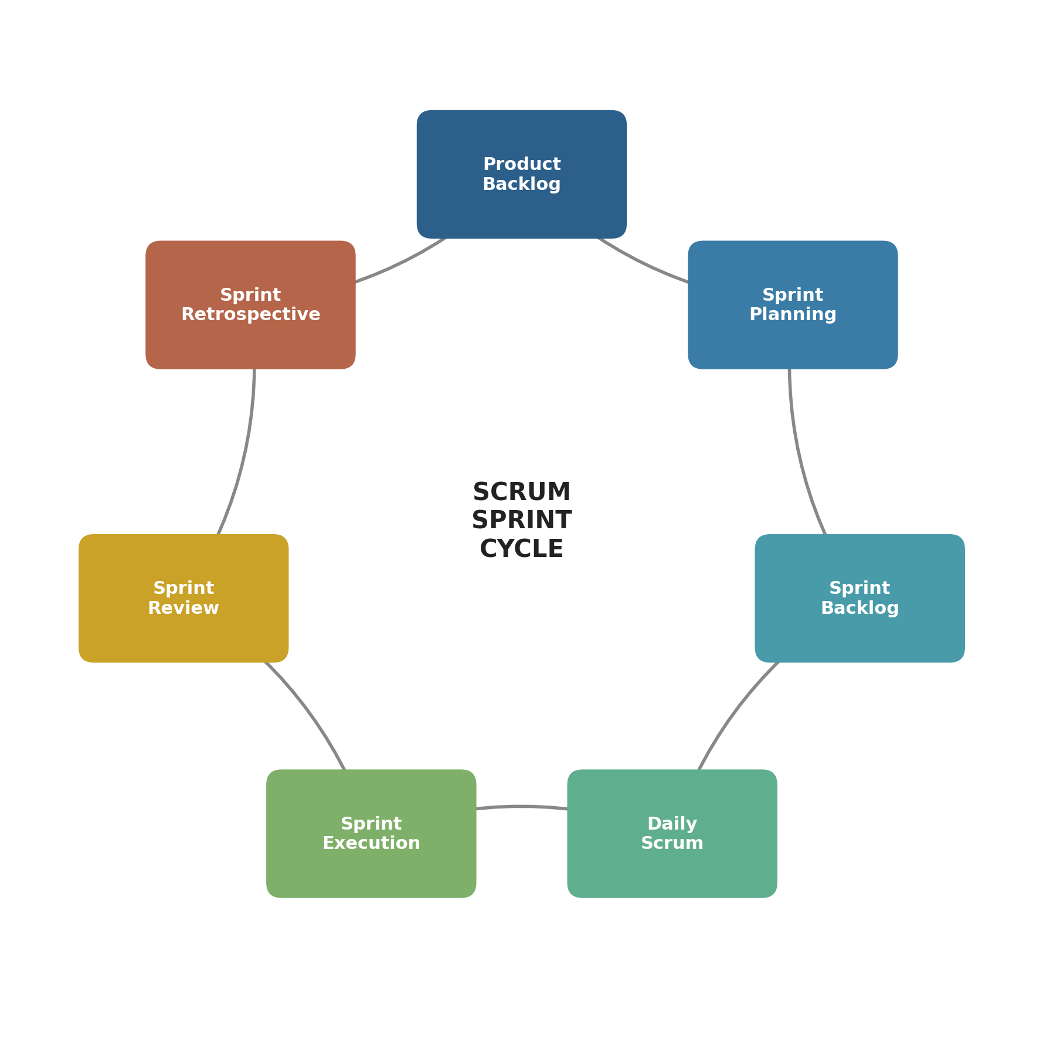
Figure 1: The Scrum Sprint Cycle — from Product Backlog through to Retrospective

3.1 Scrum Roles
Role | Responsibility on This Project
Product Owner | Represents patients, caregivers, and healthcare stakeholders; owns and prioritises the product backlog; approves completed user stories.
Scrum Master | Facilitates sprint ceremonies, removes blockers (e.g. delayed access to pharmacy APIs), and coaches the team on Agile practice.
Development Team | Cross-functional group of designers, engineers, and QA testers responsible for turning backlog items into a working increment each sprint.
Caregiver/User Representatives | Participate in the User Story Workshop and Sprint Review to validate usability for elderly patients and caregiver workflows.

3.2 Sprint Cadence
The team will work in two-week sprints. Each sprint begins with Sprint Planning and ends with a Sprint Review and Sprint Retrospective. A Daily Scrum (stand-up) of no more than fifteen minutes is held each working day to synchronise progress and surface blockers early — an important safeguard given the patient-safety implications of this product.

4. User Story Workshop
The User Story Workshop is a collaborative session bringing together the Product Owner, the development team, and caregiver/user representatives to translate the project objectives into a prioritised set of user stories. The workshop followed a structured agenda: reviewing the problem statement, identifying user personas, brainstorming candidate stories on a shared board, refining each story against the INVEST criteria, and grouping related stories into epics.

4.1 User Personas Identified in the Workshop
- Eleanor (78) — lives alone, manages five daily medications, has mild memory difficulty and limited smartphone experience.
- Raj (52) — adult son and primary caregiver, lives in a different city, checks in on his mother's adherence remotely.
- Dr. Amara — general practitioner who prescribes and periodically adjusts multi-drug regimens for elderly patients.
- Home Care Nurse — visits several elderly patients weekly and needs a quick overview of adherence trends.

4.2 The INVEST Criteria
Every candidate story generated in the workshop was tested against the INVEST criteria to ensure it was suitable for inclusion in the backlog:
- Independent — the story can be developed and delivered without a strict dependency on other stories.
- Negotiable — details can be discussed and refined until sprint planning, rather than being fixed contracts.
- Valuable — the story delivers clear value to the patient, caregiver, or healthcare provider.
- Estimable — the team has enough information to size the story with reasonable confidence.
- Small — the story fits comfortably within a single sprint.
- Testable — clear acceptance criteria exist to confirm the story is done.

4.3 Epics Identified
ID | Epic | Description
E1 | Patient Reminder Experience | Elderly-friendly interface and notification engine for medication reminders.
E2 | Caregiver Monitoring | Dashboard, adherence history, and escalation alerts for caregivers.
E3 | Medication Management | Multi-drug scheduling, dosage rules, and refill tracking.
E4 | Security & Compliance | Authentication, data privacy, and secure access controls for patient health data.

5. Product Backlog — User Stories
The following user stories were written during the workshop using the standard format: "As a <persona>, I want <capability>, so that <benefit>." Each story includes acceptance criteria and a story point estimate produced by Planning Poker (Fibonacci scale: 1, 2, 3, 5, 8, 13).
US-01 (Epic E1) | Priority: High | Story Points: 5
As Eleanor, I want large-text medication reminders with simple icons, so that I can understand what to take and when without confusion.
Acceptance Criteria:
- Reminder screen uses minimum 24pt font and high-contrast icons.
- No more than one action is required to acknowledge a reminder.
- Usability-tested with at least 5 elderly participants.
US-02 (Epic E3) | Priority: High | Story Points: 8
As Dr. Amara, I want to input and edit multi-drug dosing schedules, so that patients receive an accurate reminder plan that matches their prescriptions.
Acceptance Criteria:
- Provider can add, edit, and remove medications with dose, frequency, and time.
- System validates for conflicting or duplicate schedule entries.
- Changes take effect on the patient's next reminder cycle.
US-03 (Epic E1) | Priority: High | Story Points: 5
As Eleanor, I want to receive a notification when a medication is due, so that I do not forget to take it on time.
Acceptance Criteria:
- Push notification and audible alert trigger at the scheduled time.
- Notification repeats at a configurable interval if not acknowledged.
- Works reliably on both Android and iOS devices.
US-04 (Epic E2) | Priority: High | Story Points: 8
As Raj, I want a caregiver dashboard showing my mother's adherence history, so that I can check on her wellbeing remotely.
Acceptance Criteria:
- Dashboard displays a 7/30-day adherence history with missed-dose flags.
- Data refreshes in near real time (within 2 minutes of a logged dose).
- Accessible from a mobile browser and companion app.
US-05 (Epic E2) | Priority: High | Story Points: 5
As Raj, I want to be alerted immediately if my mother misses a dose beyond a set time threshold, so that I can check in before it becomes a health risk.
Acceptance Criteria:
- Escalation alert fires if a dose is unacknowledged after a configurable threshold (default 30 minutes).
- Alert is sent via push notification and SMS fallback.
- Caregiver can acknowledge the alert to stop further escalation.
US-06 (Epic E1) | Priority: Medium | Story Points: 8
As Eleanor, I want to confirm I've taken my medication using my voice, so that I don't need to tap small buttons.
Acceptance Criteria:
- Voice command "I took my medicine" logs the dose against the correct scheduled entry.
- Works with common regional accents tested during usability sessions.
- Falls back gracefully to a single-tap button if voice fails twice.
US-07 (Epic E3) | Priority: Medium | Story Points: 3
As Eleanor, I want to be reminded when my medication supply is running low, so that I can request a refill before I run out.
Acceptance Criteria:
- System estimates remaining supply from logged doses.
- Reminder triggers at a configurable threshold (default 5 days of supply left).
- Reminder is also visible on the caregiver dashboard.
US-08 (Epic E4) | Priority: High | Story Points: 13
As a Product Owner, I want all patient health data encrypted and access-controlled, so that the platform meets healthcare data privacy expectations.
Acceptance Criteria:
- All data encrypted in transit (TLS) and at rest.
- Role-based access control separates patient, caregiver, and provider permissions.
- Access logs are retained for audit purposes.

6. Story Point Estimation — Planning Poker
Story sizing was carried out using Planning Poker, in which each team member privately selects a card from the Fibonacci sequence (1, 2, 3, 5, 8, 13, 21) representing their estimate of relative effort, and all cards are revealed simultaneously. Where estimates diverged significantly, the highest and lowest estimators explained their reasoning and the team re-voted until consensus was reached.

6.1 Estimation Summary
Story | Title | Points
US-01 | Elderly-friendly reminder interface | 5
US-02 | Multi-drug scheduling module | 8
US-03 | Real-time medication due notifications | 5
US-04 | Caregiver adherence dashboard | 8
US-05 | Missed-dose escalation alerts | 5
US-06 | Voice-based dose confirmation | 8
US-07 | Low-supply refill reminders | 3
US-08 | Data encryption & access control | 13
 | Total Backlog Points | 55

Based on the team's historical velocity of approximately 20–24 points per two-week sprint, the full backlog of 55 points is planned across three to four sprints, with the highest-priority patient-safety stories (US-01, US-02, US-03, US-05) front-loaded into Sprint 1 and Sprint 2.

7. Sprint 1 Planning

7.1 Sprint Goal
"Deliver a working medication reminder experience for patients, with basic multi-drug scheduling and real-time notifications, so that the core adherence loop can be demonstrated end-to-end."

7.2 Sprint 1 Backlog
Story | Title | Points
US-01 | Elderly-friendly reminder interface | 5
US-03 | Real-time medication due notifications | 5
US-02 | Multi-drug scheduling module (core) | 8
 | Sprint 1 Committed Points | 18

7.3 Task Breakdown for US-01 (Example)
- Design low-fidelity wireframes for the reminder screen (UX).
- Conduct a 30-minute review session with two elderly test users.
- Implement reminder screen component in the mobile app.
- Implement large-text and high-contrast accessibility theme.
- Write unit tests for the reminder acknowledgement flow.
- QA pass with an elderly-usability checklist.
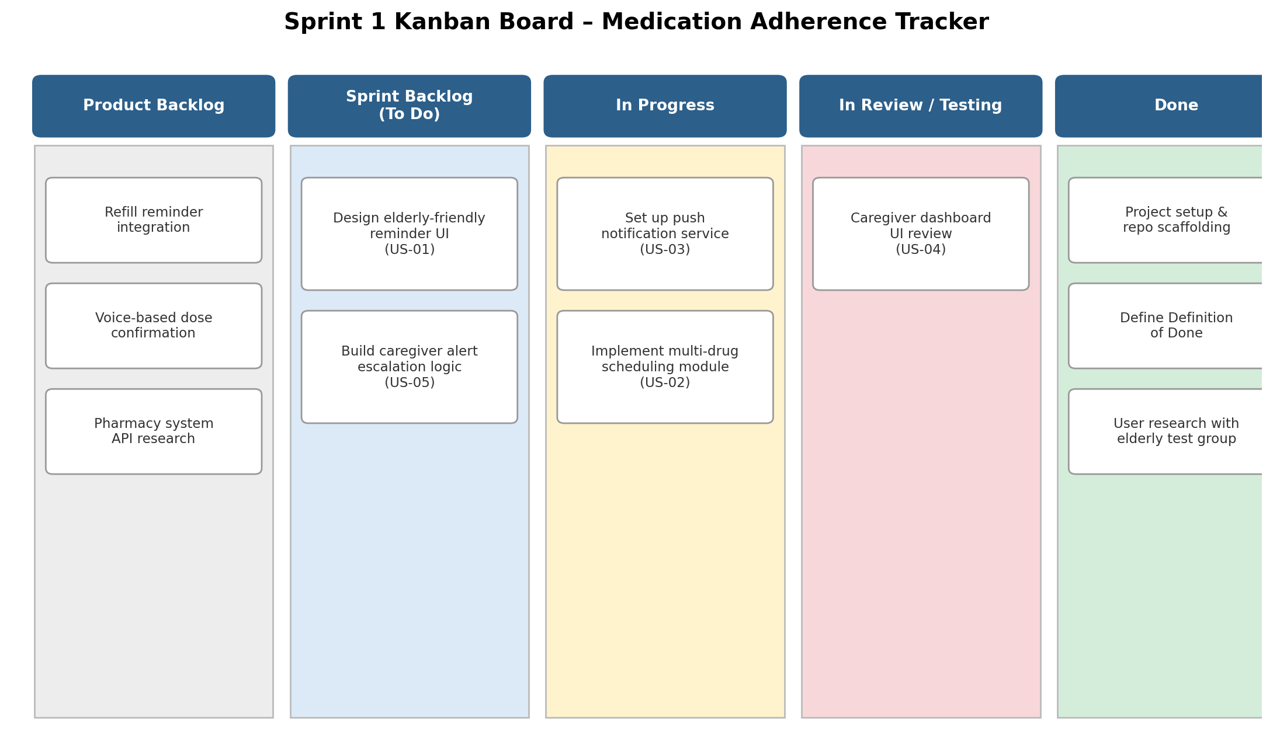
Figure 2: Sprint 1 Kanban board showing backlog items moving from To Do through to Done

7.4 Sprint Burndown
The burndown chart below tracks the team's progress against the Sprint 1 forecast. The ideal line shows the theoretical even burn rate of story points across the ten working days of the sprint; the actual line reflects a realistic pattern where progress plateaus briefly around day 3–4 (a common effect of an underestimated task within US-02) before the team recovers pace.
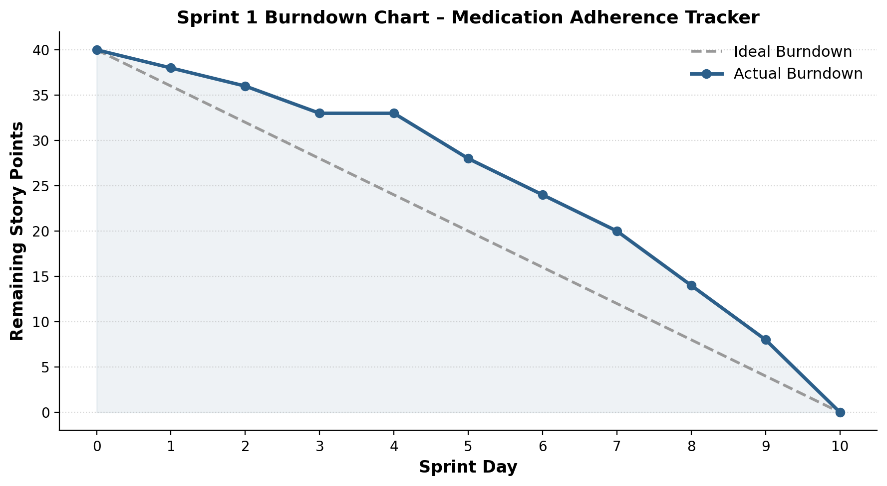
Figure 3: Sprint 1 burndown chart tracking remaining story points per day

8. Definition of Done
A user story is only considered complete when it satisfies the following Definition of Done, agreed by the whole team during backlog refinement:
- Code is written, peer-reviewed, and merged to the main branch.
- Unit and integration tests are written and passing.
- The story's acceptance criteria have been verified by QA.
- Accessibility requirements for elderly users have been checked (font size, contrast, tap targets).
- The feature has been demonstrated to the Product Owner in a sprint review.
- Documentation (user-facing and technical) has been updated.
- No known critical or high-severity defects remain open against the story.

9. Release Plan and Sprint Timeline
The MVP will be delivered across four two-week sprints, moving from the core reminder engine through to caregiver features, voice and refill capabilities, and finally security hardening and release readiness.
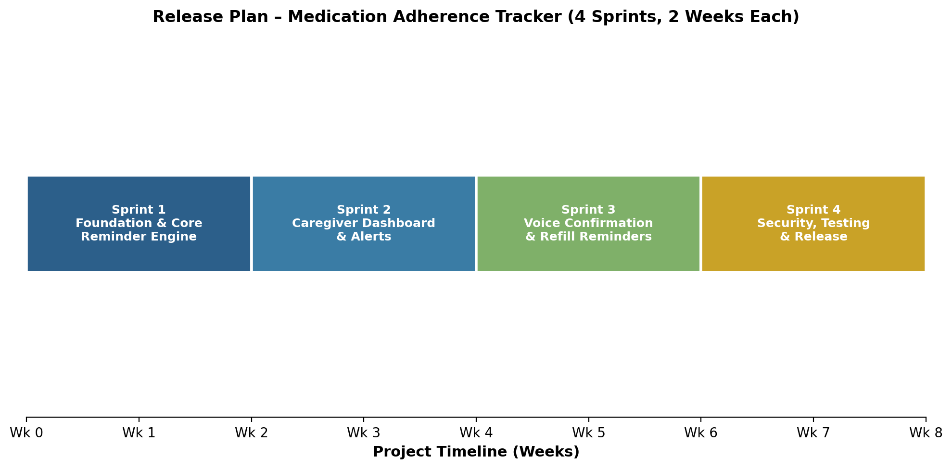
Figure 4: Eight-week, four-sprint release plan for the MVP

9.1 Sprint-by-Sprint Themes
Sprint | Theme | Key Stories
Sprint 1 | Foundation & Core Reminder Engine | US-01, US-03, US-02 (core)
Sprint 2 | Caregiver Dashboard & Alerts | US-04, US-05, US-02 (advanced rules)
Sprint 3 | Voice Confirmation & Refill Reminders | US-06, US-07
Sprint 4 | Security, Testing & Release | US-08, hardening, end-to-end QA, release prep

10. Risks and Mitigation
Risk | Impact | Mitigation
Voice recognition accuracy for elderly speech patterns | Reduced usability of US-06 | Prototype early with real users; provide a one-tap fallback.
Underestimation of multi-drug scheduling complexity | Sprint 1 spillover | Split US-02 into core and advanced rules across two sprints.
Data privacy / compliance requirements evolve | Rework of US-08 | Engage a compliance reviewer before Sprint 4 begins.
Limited availability of elderly test participants | Delayed usability validation | Recruit a standing panel of test users at project start.

11. Expected Outcomes
- Improved medication adherence among elderly patients through timely, accessible reminders.
- Reduced risk of missed doses and related health complications through real-time caregiver alerts.
- Enhanced peace of mind for family members and caregivers monitoring patients remotely.
- Greater independence for elderly patients, reducing reliance on constant in-person supervision.
- Faster response to adherence issues through immediate escalation notifications.
- Reduced hospital readmissions and healthcare costs associated with medication non-adherence.
- Improved coordination among multiple caregivers or family members.
- A scalable foundation adaptable for future integration with pharmacies and healthcare provider systems.

12. Conclusion
The Agile Sprint Planning and User Story Workshop process described in this report demonstrates how a broad healthcare problem — supporting medication adherence for elderly patients — can be systematically broken down into prioritised, estimable, and testable user stories. By applying the INVEST criteria, Planning Poker estimation, and a clear Definition of Done, the team has produced a Sprint 1 plan with a focused sprint goal and a realistic four-sprint release plan for the MVP.
This structured approach ensures that the highest-value, highest-risk items — the core reminder experience, multi-drug scheduling, and caregiver escalation alerts — are addressed early, while lower-priority enhancements such as voice confirmation and refill reminders follow in later sprints. The use of visual artefacts such as the Kanban board, burndown chart, and release timeline supports transparent tracking and communication with stakeholders throughout delivery.

